Лабораторная работа 1 собственные значения

Вариант 16

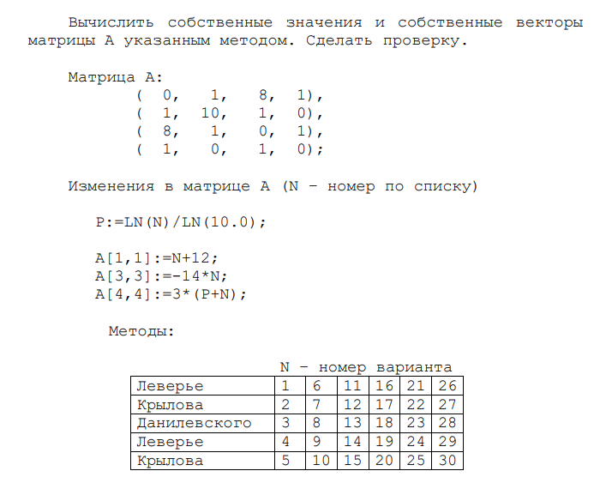

Метод Леверье

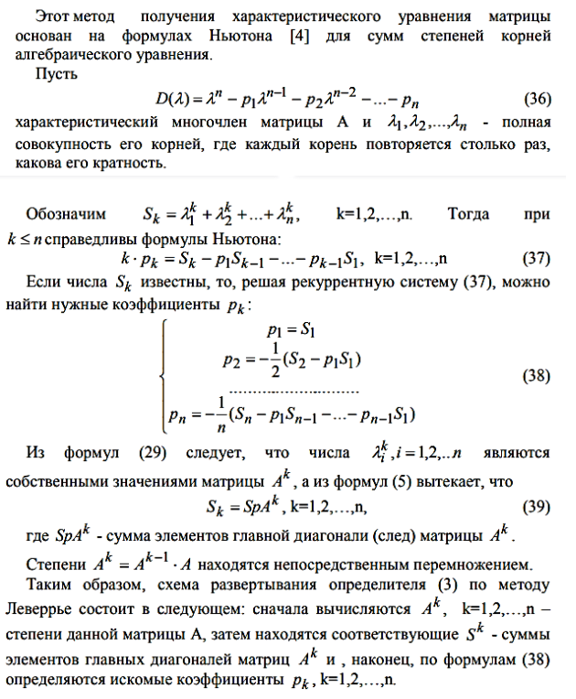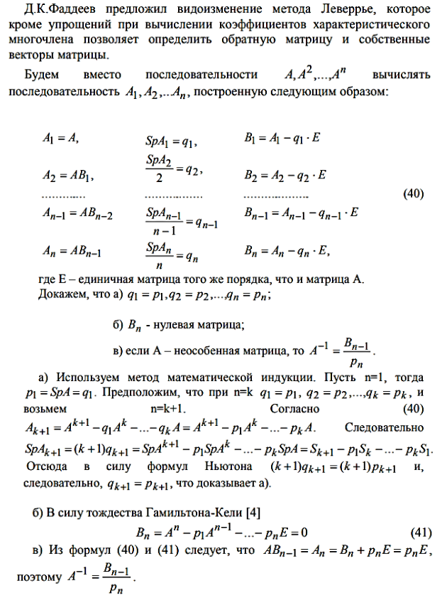

N = len(A)

A_main = A

E = [[0 for _ in range(N)] for _ in range(N)]

p_list = []

B_list = [[] for i in range (N)]

for i in range(0,N):

E[i][i] = 1

for k in range(1,N):

p = 0

for i in range(N):

p += A[i][i]

p = (1/k) * p

p_list.append(p)

B = matrix_sub(A, scalar_multiply(E, p))

for i in range(len(B)):

B_list[k].append(B[i][0])

A = MatrixMatrixMult(A_main, B)

p = 0

for i in range(N):

p += A[i][i]

p = (1/N) * p

p_list.append(p)

A_inv = scalar_multiply(B, 1/p)

**Характеристическое уравнения для нахождения собственных значений**

def f(x,A):

return x**4 - x**3 * A[0] - x**2 * A[1] - x * A[2] - A[3]

**Решения характеристического уравнения методом бисекций**

res = []

for i in range(-500, 500):

x = bisection(i, i+1, p_list)

if x != 0:

res.append(x)

print(x)

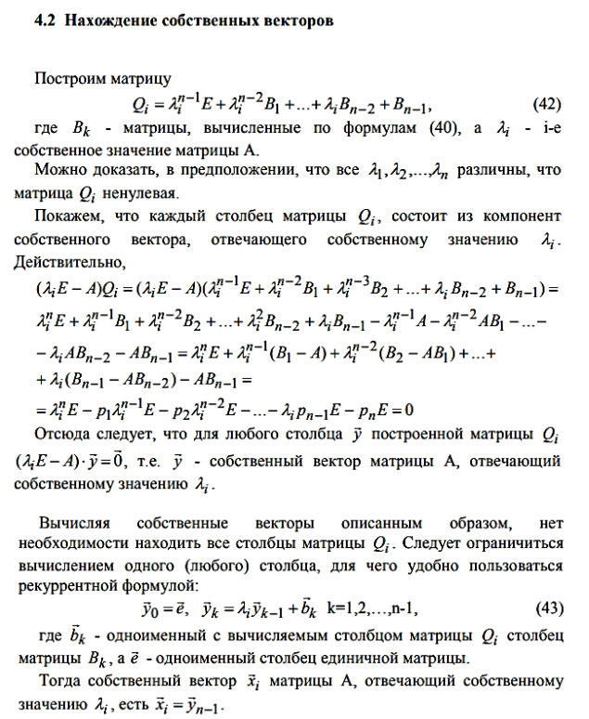

y0 = [1,0,0,0]

y = []

for i in range(N):

y1 = vector_add(scalar_multiply_vector(res[i], y0), B_list[1])

y2 = vector_add(scalar_multiply_vector(res[i], y1), B_list[2])

y3 = vector_add(scalar_multiply_vector(res[i], y2), B_list[3])

t = length(y3)

print(t)

y.append(t)

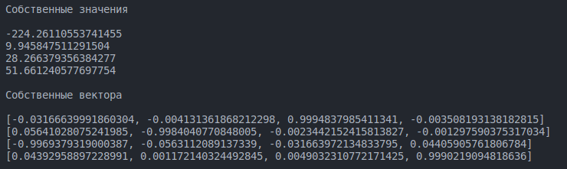

Проверка $A*x = λ*x$

for i in range (len(x)):

res = vectors_sub(MatrixVectorMult(A, x[i]), scalar_multiply_vector(l[i],x[i]))

print(res)

